**DAILY ASSESSMENT FORMAT**

|  |  |  |  |
| --- | --- | --- | --- |
| **Date:** | **20-May-2020** | **Name:** | **Russell D’souza** |
| **Course:** | **TCS iON** | **USN:** | **4AL15EC023** |
| **Topic:** | **Ace corporate,corporate etiquette,writing effective EMAILS** | **Semester & Section:** | **8th sem & ‘A’ section** |
| **Github Repository:** | **Russell1005** |  |  |

|  |
| --- |
| **MORNING SESSION DETAILS** |
| **Image of session** |

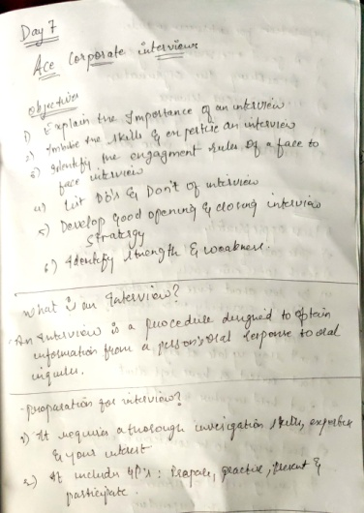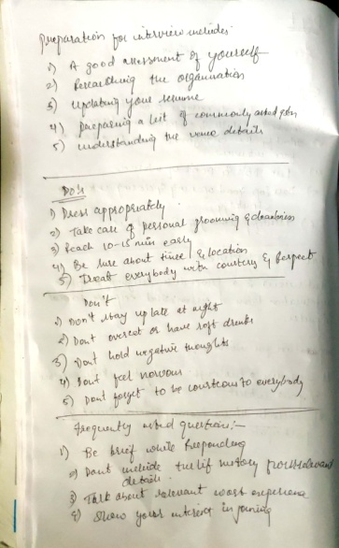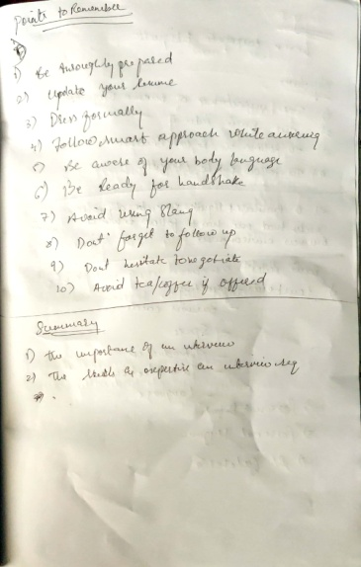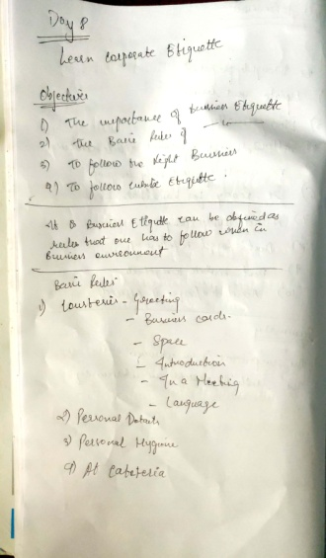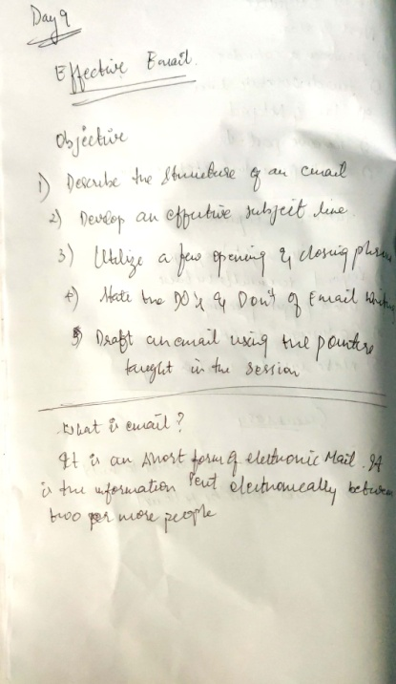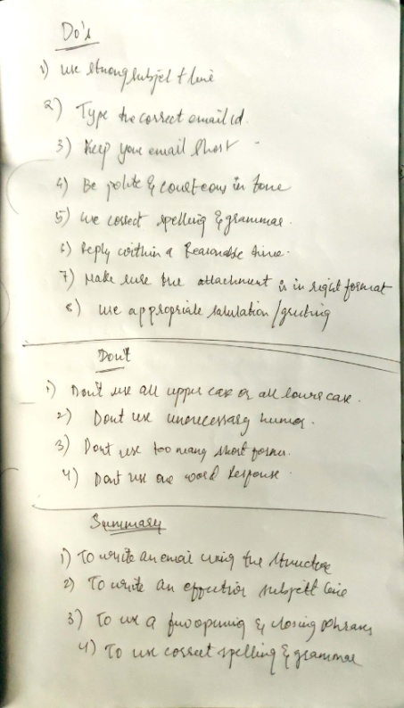

**DAILY ASSESSMENT FORMAT**

|  |  |  |  |  |  |  |  |  |  |  |  |  |  |  |  |  |
| --- | --- | --- | --- | --- | --- | --- | --- | --- | --- | --- | --- | --- | --- | --- | --- | --- |
| |  |  |  |  | | --- | --- | --- | --- | | **Date:** | **20-5-2020** | **Name:** | **Russell D’souza** | | **Course:** | **Python programming** | **USN:** | **4AL15EC023** | | **Topic:** | **Build an interactive English dictonary** | **Semester & Section:** | **8th A** | | **Github Repository:** | **Russell1005** |  |  | |
|  |
|  |
| **AFTERNOON SESSION DETAILS** | |
| **Image of session** | |
| **Dictionary** in Python is an unordered collection of data values, used to store data values like a map, which unlike other Data Types that hold only single value as an element, Dictionary holds key:value pair. Key value is provided in the dictionary to make it more optimized. Each key-value pair in a Dictionary is separated by a colon :, whereas each key is separated by a ‘comma’.  A Dictionary in Python works similar to the Dictionary in a real world. Keys of a Dictionary must be unique and of immutable data type such as Strings, Integers, and tuples, but the key-values can be repeated and be of any type.  **Modules needed:**   * **json:**It comes built-in with python, so there is no need to install it externally. To know more about JSON [click here](https://www.geeksforgeeks.org/javascript-json/). * **difflib:**This module provides classes and functions for comparing sequences. It also comes built-in with python so there is no need to install it externally.   **Steps:**   1. Download a JSON file containing English dictionary words in a python dictionaries data type format, or arrange the file content in that way. 2. Create a folder and add the downloaded .json file and python script in that folder. 3. In python editor, import the required modules.   **BELOW IS THE IMPLEMENTATION OF IT:**  # Import the modules required  import json  from difflib import get_close_matches    # Loading data from json file  # in python dictionary  data = json.load(open("dictionary.json"))    def translate(w):      # converts to lower case      w = w.lower()        if w in data:          return data[w]      # for getting close matches of word      elif len(get_close_matches(w, data.keys())) > 0:          yn = input("Did you mean % s instead? Enter Y if yes, or N if no: " % get_close_matches(w, data.keys())[0])          yn = yn.lower()          if yn == "y":              return data[get_close_matches(w, data.keys())[0]]          elif yn == "n":              return "The word doesn't exist. Please double check it."          else:              return "We didn't understand your entry."      else:          return "The word doesn't exist. Please double check it."    # Driver code  word = input("Enter word: ")  output = translate(word)    if type(output) == list:      for item in output:          print(item)  else:      print(output)  input('Press ENTER to exit')  Important, the output should not vary with different cases such as upper case and lower case input of same text should be same i.e rain or Rain or RaIn should produce same output. Also if user mistakes with spelling of word it should return the close words related to the word input or print a user friendly message that word does not exist.  **INPUT:**  rain  **OUTPUT:**  **dictionary-python-script** | |